When reviewing the treatment plan with the individual and family (which should be at least Quarterly, some programs do it more frequently) you may find that you need to edit the end date to expire a goal/ objective due to mastery and add a new one (or maybe you just need to add a new one!).
Step One: As you are in your “Progress Toward Plan” tab within the Quarterly Review visit for your program, you will see the below image, where you document your progress and other information. To add EDIT (remember edit can be expiring a goal, adding a goal, or changing any part of the TxPlus click one of the buttons highlighted below that matches your needs best (these options are on the bottom of each “box” in the TxPlus).
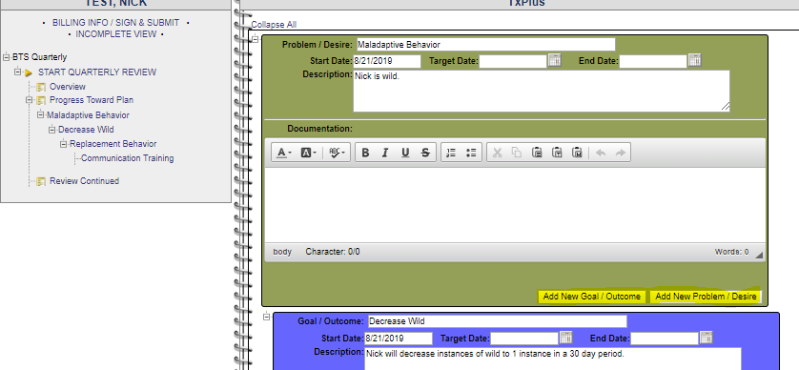
Step Two: This will open a TxPlan editing format! Yay!!! Now you add the information that you have identified as needing to be changed/ added! IMPORTANT! You must ensure that the date of this added information reflects the date you are obtaining the signatures from the family/ the date of the quarterly. YOU MUST GET A SIGNATURE on the QR FOR ANY CHANGES, just like a signature for an initial plan is required. 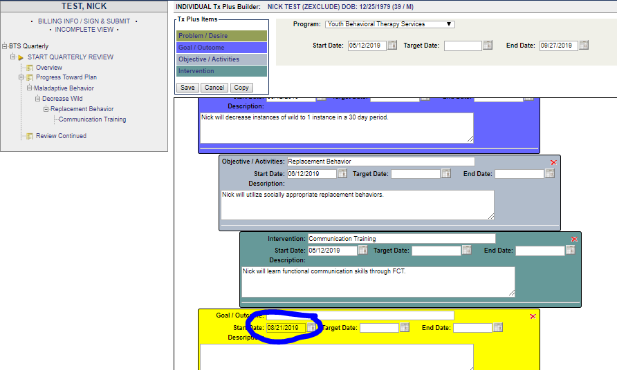
Step 3: Save the plan as normal, and if all your dates line up (like you are doing this at the time of the meeting with the individual/ family) it will inject into your service. Once it injects, you can make a documentation note- You should make a quick note about this goal being added and why! Note: To ensure your plan saves, please look on the left of the visit in the “notebook” section under Progress Toward Plan that the added or removed goals match your changes. If this does not match, please do not sign and submit until they match.
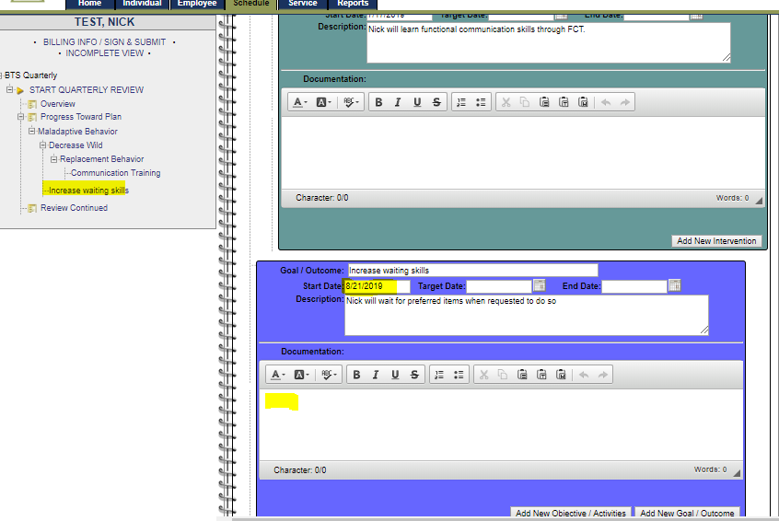
Step 4: In the review tab: If you are making any changes, it is important that you also reflect that in the first question on the review tab. Example: New intervention added to treatment plan for Psychiatric services.
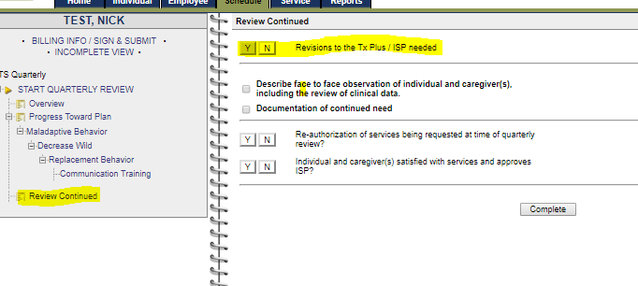
Step 5: You must get individual and caregiver/ guardian signatures- and that signature date must match the start date of your added information to the TxPlan.
When an item on the tx plus has been completed and needs to be lapsed out you can click on “individual intake” on the left under the individual’s name.

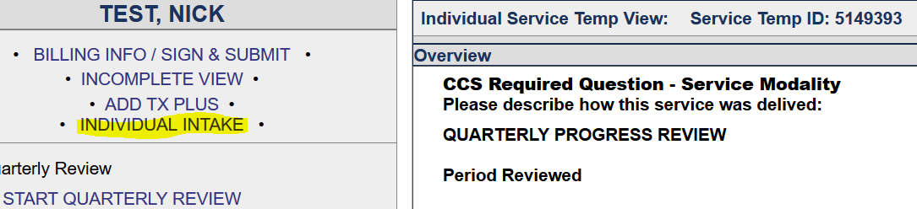
This will allow you to click on the tx plus tab and go into the tx plus. From there you select edit and enter a new end date in the item you have compelted and want to expire and click “save”.
